**i.** Display student names along with the department name.

select name,deptname from student,department where student.deptcode=department.deptcode;

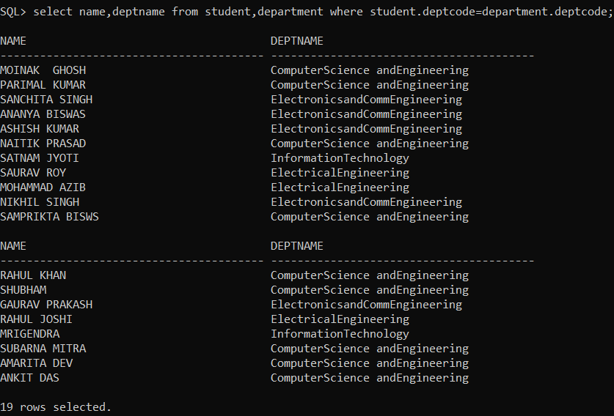

**ii.** Display student names, subject code and marks of students who took admission in the year 2017 and read subject CS502.

select name,marks from student,result where yearofadm=2017 and sub_code='CS502' and student.roll_no=result.rollno;

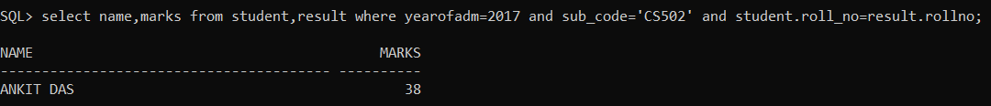

**iii.** Find the name of the students who got marks between 70 to 89 in CS501.

select name from student,result where result.marks between 70 and 89 and sub_code='CS501' and student.roll_no=result.rollno;



**iv.** Find the student name, roll no who appeared in the examination for paper DBMS.

select name,roll_no from student,result where sub_code='ECS501' and student.roll_no=result.rollno;

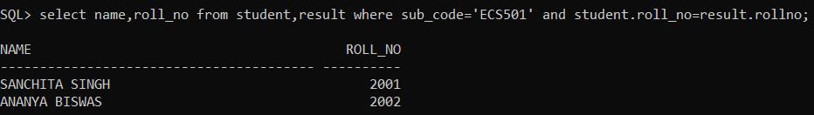

**v.** Show student names, subject code and marks for CSE 3rd year students

select name,sub_code,marks from student,result where semester='SEM5' and deptcode='CSE' and student.roll_no=result.rollno;

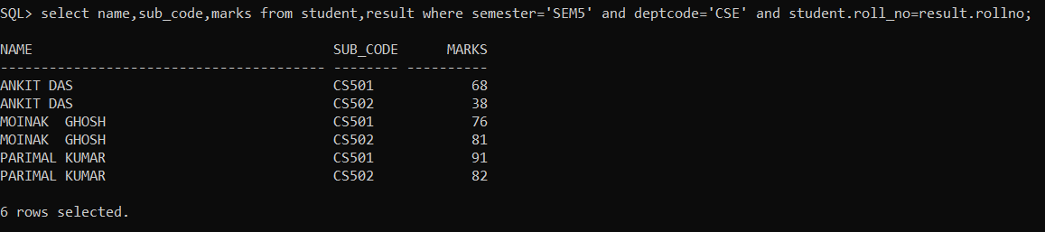

**vi.** Show student names, department name for 5 th semester students who born in MAY.

select name,deptname from student,department where semester='SEM5' and birth_date like '%-MAY-%' and student.deptcode=department.deptcode;

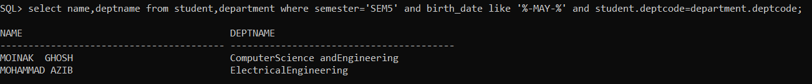

**vii.** Show student names, subject name for 5th semester student where subject name contains the word ‘DATA’

select name,subjectname from student,subject where student.semester='SEM5' and subjectname like '%Data%' and student.semester=subject.semester;

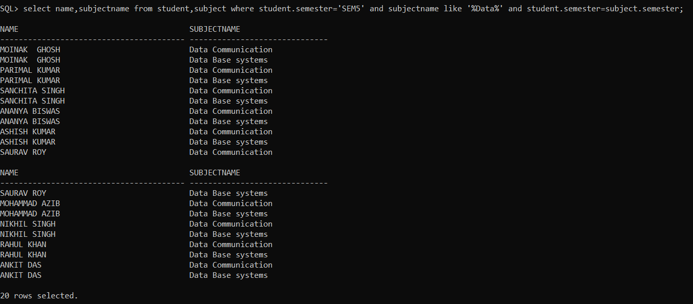

**viii.** Show student names, subject name and marks for 5th semester students.

select name,subjectname,marks from student,subject,result where student.semester='SEM5' and student.roll_no=result.rollno and subject.subjectcode=result.sub_code;

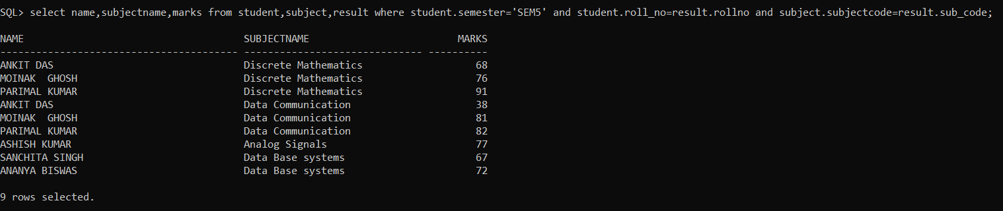

ix. Find the roll number, student names and marks for CSE students who get more than 80 in Data Structure.

select rollno,name,marks from student,result where deptcode='CSE' and sub_code='CS301' and marks>80 and student.roll_no=result.rollno;

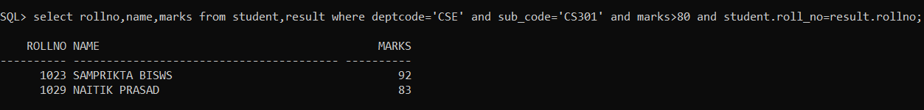

**x.** Show student names, department name, subject name and subject wise marks for which the student get more than 90.

select name,deptname,subjectname,marks from student,department,subject,result where marks>90 and student.roll_no=result.rollno and student.deptcode=department.deptcode and subject.subjectcode=result.sub_code;



**xi.** Add column HOD in DEPARTMENT. Insert faculty id in place of HoD.

alter table department add HOD varchar2(4);

update department set HOD='F01' where deptcode='CSE';

update department set HOD='F02' where deptcode='ECE';

update department set HOD='F03' where deptcode='EE';

update department set HOD='F04' where deptcode='IT';

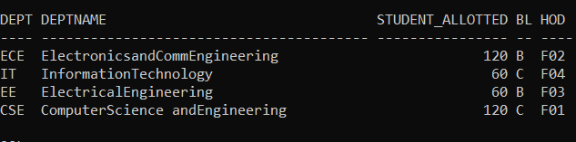

**xii.** Add column TEACHER in table SUBJECT. Insert faculty id in this column.

alter table subject add TEACHER varchar2(4);

update subject set TEACHER='F01' where subjectcode='CS301';

update subject set TEACHER='F02' where subjectcode='CS302';

update subject set TEACHER='F03' where subjectcode='CS501';

update subject set TEACHER='F04' where subjectcode='CS502';

update subject set TEACHER='F05' where subjectcode='CS503';

update subject set TEACHER='F06' where subjectcode='EC501';

update subject set TEACHER='F07' where subjectcode='ECS501';

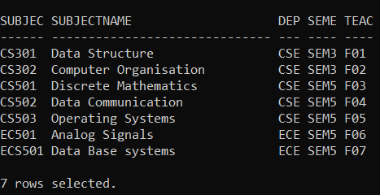

**xiii.** Show the department name, semester, subject name along with faculty name.

select deptname,subjectname,semester,faculty.name from department,subject,faculty where subject.deptcode=department.deptcode and faculty.fid=subject.teacher;

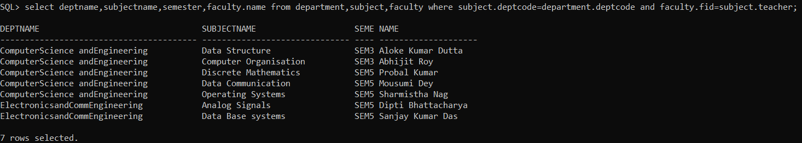

**xiv.** Find the names of all faculties whose HOD name is given.

select name from faculty where fid in (select HOD from department);

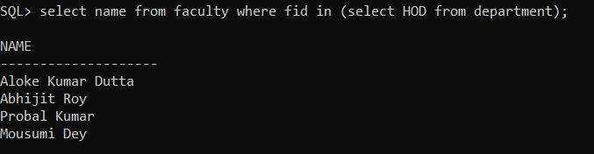

**xv.** Display subject name, subject code, marks including all subjects. [Outer join ]

select subjectname,sub_code,marks from subject left outer join result on subject.subjectcode=result.sub_code;

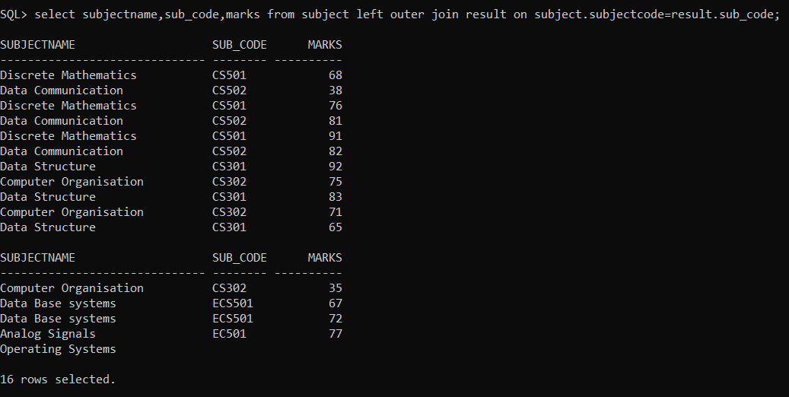

**xvi.** Display students name, subject code, marks. Include all students. [Outer join ]

select name,sub_code,marks from result right outer join student on result.rollno=student.roll_no;

